Organizational chart

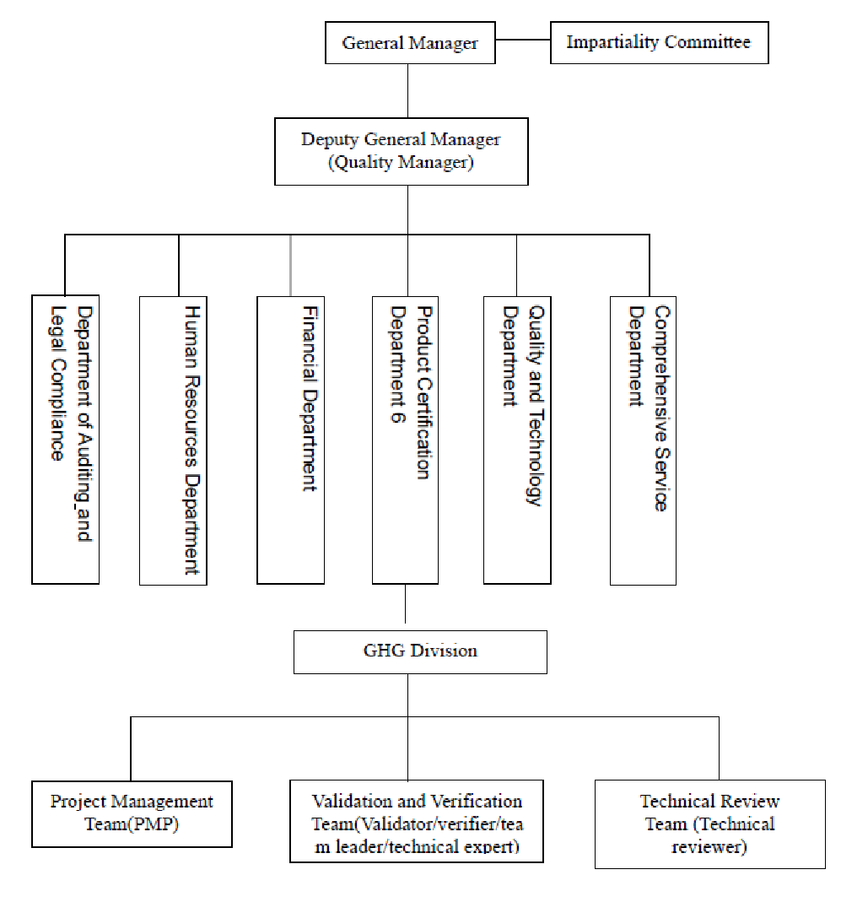

List of Management Personnel
Name | Department | Position
Liu Gang | CQC | General Manager/Quality Manager
Li Yafang | Human Resources Department | Manager
Wu Qin | Financial Department | Deputy Manager
Cui Xiaojuan | Department of Auditing and Legal Compliance | Deputy Manager
Liu Xin | Comprehensive Service Department | Manager
Wu Lan | Quality And Technology Department | Manager
Zhang Lixin | PCD-6 | Deputy Manager

Responsibilities of Management Personnel

Position | Responsibilities
CQC general manager | 1. Formulation and development of CQC quality policy and objectives and ensure their implementation in an effective way;  2. Establishment of a quality management system in line with policies formulated;  3. Decisions relating to disputes & judicial processes and complaints;  4. Determine the human resource requirements for CBAM verification function;  5. to be responsible for the overall management of CQC CBAM verification work, organizing and coordinating all CQC work.  6. to allocate and manage funds needed for operating CBAM verification work, and keep finance situation stable.  7. to approve quality manual and corresponding procedures.  8. to be responsible for management review of CBAM verification;  9. to provide to Impartiality Committee all information regarding CBAM verification, including reasons of all important decisions.
CQC vice  general manager  (Quality Manager) | - to assist General Manager to realize quality policy and objectives;  - Documentation of policies and procedures and their implementation;  3. to manage CBAM verification with the authorization of CQC General Manager;  4. Final decisions on verification activities;  5. to implement, maintain and improve CQC quality management system according to CBAM accreditation requirements;  6. to supervise and monitoring of implementation of policies and verification procedures, and coordinate with relevant departments involved in CBAM verification work to ensure normal operation of CQC quality system;  7. Supervise finances, administrative matters and dealing with contractual matters and arrangements, following CQC specific requirements;  8. to approve qualifications of all personnel involved in CBAM verification; be responsible for periodic monitoring of the performance of management personnel except top management);  9. to approve annual internal audit plan;  10. to report to CQC General Manager about the operation of quality management system so as to conduct management review;  11. to approve the application of new sectoral scopes;  12. to be responsible for periodic monitoring of other management personnel (i.e. manager of Q&T Dept. etc.) not including top management；  13. to be responsible for verifying the effectiveness of corrective/preventive actions taken by several departments  .
Manager of A&L Dept. | 1. to be responsible for the management of the various legal affairs of the Center, including handling Appeals,Complaints and Disputes & Judicial processes among others  2. to be responsible for developing corrective/preventive actions and verifying the effectiveness of them.
Manager of HR Dept. | 1. to be responsible for the recruitment of a full-time CQC employment;  2. to establish CQC legal status and organizational chart;  3. to be responsible for developing corrective/preventive actions and verifying the effectiveness of them.
Manager of Financial  Dept. | 1. to monitor CQC’s income and expenditure to determine the financial stability and financial resources required for its operations of the CBAM related activities.  2. to manage of risk funds.  3. to be responsible for developing corrective/preventive actions and verifying the effectiveness of them.
Manager of CS Dept. | 1. to undertake daily work of Impartiality Committee secretariat；  2. to deal with appeals and Complaints submitted to the Impartiality Committee；  3. Information publication work；  4. to manage files and records;  5. to be responsible for developing corrective/preventive actions and verifying the effectiveness of them.
Manager of Q&T Dept. | - to be responsible for formulating, revising and controlling CBAM verification quality manual and procedures.  2. to undertake daily supervision and management of effectiveness and compliance of the internal quality system operation.  3. to assist quality manager to implement internal audit of CBAM verification quality management system.  4. to assist CQC General Manager to organize management review of CBAM verification.  5. to be responsible of impartiality and confidentiality of CBAM verification work.  6. to be responsible for evaluation of CABM management personnel (including top management personnel) and the personnel to be involved in verification activities, prior to their recruitment; be responsible for periodic monitoring the performance of evaluator of industrial sector specific competence, internal auditors, and the top management.  7. to provide training to personnel involved in CBAM project;  8. to be responsible for developing corrective/preventive actions and verifying the effectiveness of them.
Manager of PCD-6 | 1. to be responsible for communication with accreditation body.  2. to manage CBAM verification accreditation scopes and application of possible new scopes.  3. to analyze and the human resource requirements;  4. to accept CBAM verification contract;  5. to sign CBAM verification contract (subject to CQC specific requirements);.  6. to select the technical team as well as the verification team to implement CBAM verification activity.  7. to implement independent review of verification report.  8. to collect CBAM related specifications and regulations.  9. to propose training needs;  10. to suggest the developing and revision of CBAM Quality Manual and Procedures;  11. to be responsible for periodic monitoring of PMP, verifier, lead verifier, technical experts and independent reviewer;  12. to be responsible to make sure the documents that need to be made available to public to be the latest version;  13. to be responsible for developing corrective/preventive actions and verifying the effectiveness of them.

